Lab 6.2 Using env

1. Create a pod-definition.yml file as below:

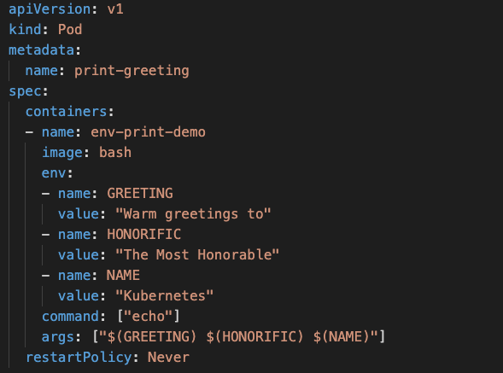

1. Create the Pod

**kubectl create -f pod-definition.yml**

1. Check the Logs in the Pod

**kubectl logs -f print-greeting**

1. Delete the pod

**kubectl delete pod/print-greeting**